**4.2 Arduino (Jeff F.)**

The programming of the robotic arm's movement comes from the Adafruit METRO 328 microcontroller, which is similar to an Arduino Uno, but slightly more user-friendly. Just like an Arduino microcontroller, it is programmable with an IDE such as the Arduino IDE. The four LEDs are placed on the edge of the PCB so that they are seen easier when the METRO has a shield mounted on top of it. For easier debugging, these indicator LEDs have one green power LED, two RX/TX LEDs, and a red LED connected to pin PF5. Adafruit designed this microcontroller specifically to run the Atmega328 brain, which has 32 KB of Flash and 2 KB of RAM, running at 16 MHz and preloaded with the Optiboot bootloader. The METRO has an FTDI USB-to-Serial converter for the purpose of sending and receiving data to a computer. The logic level is at 5-V, but could convert to 3.3-V logic if required[1].

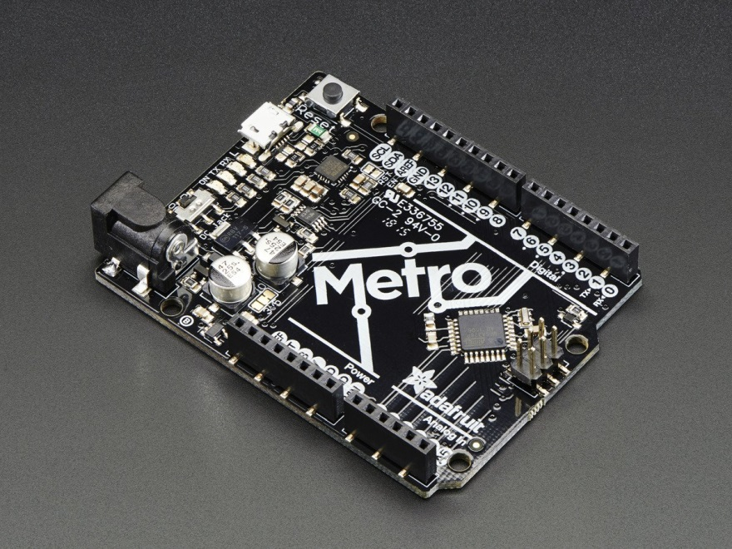

**Figure:** Adafruit METRO 328

**4.3 Xbee (Jeff F.)**

The Digi International XBee 802.15.4 module manages the wireless data communication from the computer to the robotic arm. It operates on a 2.4GHz frequency to transmit data to a receiver. To connect the transmitter to the Arduino, it must attach to an Xbee adapter, and then connected to an Arduino shield stacked on top of the Arduino Uno microcontroller. The receiver mounts on the SSC-32 microcontroller to communicate with the Arduino without needing to wire the two boards together.

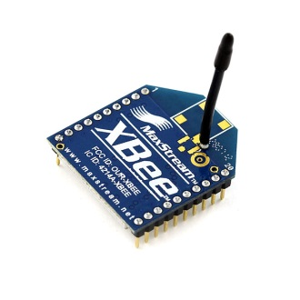

**Figure:** XBee 802.15.4 module

[1] "METRO Development Boards with ATmega328." *Digikey*. N.p., n.d. Web. <https://www.digikey.com/en/product-highlight/a/adafruit/metro-development-boards-with-atmega328>.